**Mark Eatough**

**CSIS 2430 9:00 Class**

**Programming Project 8**

**Database Program**

**Assignment objective:**

Setup a database to handle the final project.  Choose any SQL or NoSQL database.  Take a screen shot of the work and submit.

**What Worked?:**

Once I got everything set up moving the data that I had hard coded into my programs was pretty easy. I created train travel objects which included start city, end city, travel time, and cost. I added all of these items to a list, and then iterated through the list adding each item to the corresponding column.

**What did not work?:**

The hardest part about this project was getting MySQL setup to work with everything on my machine. The first time I attempted to do the download I must have done something wrong because the Command line client would not execute when I clicked on the icon, and when I tried to access it via command prompt I got a message saying access denied. I spent several hours trying to get this to all come together, before uninstalling and re-installing MySQL which then worked.

**Comments:**

I had never used any sort of database before this assignment. While I was frustrated getting everything set up I feel like I learned a lot doing it. It is easy to see how being able to import data from a database or export data to a database will be a valuable skill and a huge time saver for me someday in the future.

Data imported from database and printed using python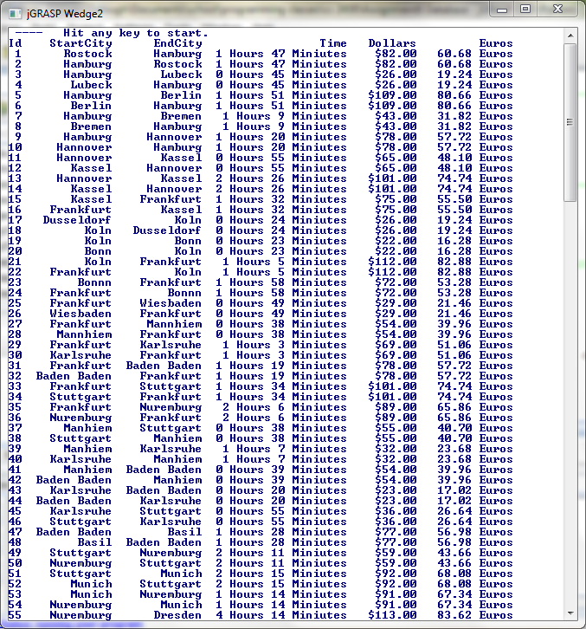

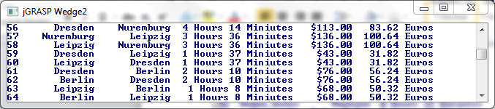

Data sent to MySQL database through python

